Week 1 Workshop Worksheet

## Complete the Statistical ‘Which Character are you?’ Task

Our first task will be to complete an online personality inventory that has been developed by openpsychometrics.org.

Some notices first:

* You do not have to complete it if you do not want to
* You don’t have to complete it accurately if you don’t want to
* You are under no participate in the extra study and to submit the data to the wider pool (although you are welcome to if you wish)

[Statistical "Which Character" Personality Quiz (openpsychometrics.org)](https://openpsychometrics.org/tests/characters/)

### Briefly:

* You will be presented with 36 pairs of words
* These will ostensibly be ‘opposites’ (e.g. introvert, extrovert)
* Graphical user interface, text, application

  Description automatically generatedDecide how much more like one word you are than the other by clicking on the line

You can do the normal, short, or long versions – with or without Emoji….

The 36 item one is sufficient! But you can do the longer one if you like!

I spammed the survey and didn’t save the results:

**Character (Universe):** The series that you profile is being compared to. In the above it’s saying I was most like Arya Stark from Game of Thrones. You can choose different universes to check – is your favorite show in there?

**Algorithm:** Correlates your trait profile with the character (highest correlation wins), or takes the difference in means between you and all characters (smallest difference wins).

**Similarity:** How good a **(statistical)** match were you tocharacter?

Scatterplot of your score on the traits against the rated score. There’s no measurement error in my responses because I mashed the highest to the right:

|  |  |  |
| --- | --- | --- |
|  | Best match universe | Favourite universe |
| Character |  |  |
| Universe |  |  |
| Match |  |  |
| Is there much difference based on algorithm? |  |  |
| Do you agree with the result? |  |  |
| Would your friends agree with the result? |  |  |

## Critique the Statistical ‘Which Character are you ‘ Task

Read: “Is this test accurate?” At the bottom of the page and discuss the following questions in groups:

|  |  |
| --- | --- |
|  |  |
| How many participants rated the characters? |  |
| What information does the author think it can provide? |  |
| Do you think a peer report version would give more valid findings? (give it a try if you like!) |  |
| What are some of the problems with online personality questionnaires? |  |
|  |  |

## Open and briefly use Jamovi

We’re opening (a super short version of) the Usche Dataset but only once and we’ll never use it again!

Variables are:

* Gender
* Age
* Three MBI totals
* GHQ 1-12
* GHQ total

We’re going to run through some of the basic functions available on Jamovi:

* Descriptive Statistics
* Correlations
* Graphs

## Descriptives

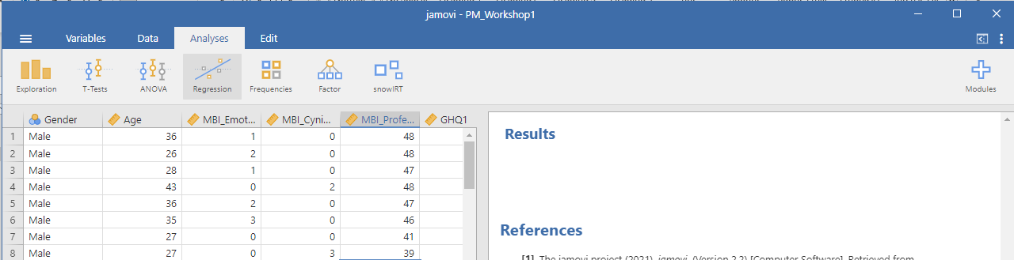

Analysis Tab:

Exploration Button

* Click Descriptives
* Select a variable and click right arrow:

Results appear immediately on the right hand side of the screen!

* Get more information from the statistics drop-down

### Plots

Plots dropdown under Explore-> Descriptives for really simple and attractive graphs

* Graphical user interface, application

  Description automatically generated

Tasks – Choose two variables and find the following:

|  |  |  |  |  |
| --- | --- | --- | --- | --- |
|  | Mean | SD | Range | Mode |
| Variable |  |  |  |  |
|  |  |  |  |  |
|  |  |  |  |  |

Plot a histogram of GHQ Total – is it normal? Paste it below:

What are the means and SDs for the following items of the GHQ?

|  |  |  |  |
| --- | --- | --- | --- |
| GHQ | Mean | SD | Normally distributed? |
| 1 |  |  |  |
| 5 |  |  |  |
| 7 |  |  |  |